**# How to enter your Balsam fir data**

Below are two methods that you may use to submit your Balsam fir data as a comma separated variable (.csv) file:

1. Using Microsoft Excel (or similar) and GitHub Desktop or
2. Create a file directly in the GitHub repository

Both approaches will require Github credentials.

**## 1) Using Microsoft Excel (or similar) and GitHub Desktop**

1) Open Excel and enter your data.

2) Save as a csv file. You should choose a name for your file that is distinct from any other files in the Lab 2 directory of the Github repository (i.e., try not to give your file the same name as another group might choose).

Save into the “Lab 2” folder of your class files, and make sure you have “master” branch and “BIOL-3295” selected in Github Desktop.

Select "File" -> "Save As..." -> In the "Format" drop-down menu select "Comma-Separated Values (.csv)" -> Click "Save". This may prompt the warning "This workbook contains features that will not work or may be removed if you save it in the selected file format. Do you want to continue?" - Click "Continue" to proceed with saving the file. If you are prompted by an additional warning concerning the encoding of the file, select the option "UTF-8 encoding" to prevent including unwanted special characters in your file.

Sometimes you will try to exit and be asked “Do you want to save the changes you made to …csv”. If you click “Save” and try and exit the same message will appear again, but you can click “Don’t Save”, and as long and no new changes have been make your file will be saved.

3) Go to Github Desktop and make sure you have “BIO-3295” as the repository and “master” branch. Pull any new files from the origin. You may need to discard changes to do this (Select “Branch” from the top tool bar and then “Discard All Changes” – you may want to rename any files you have worked on before doing this or they will be discarded. For more details read “Working with the class Github repository.pdf” in the “Handouts” folder.)

4) Commit your changes to the “master” branch using the big blue button at the bottom left of Github Desktop. (Note that for you the repository should be “BIOL-3295”, in the photo below I’m just trying an example on a repository where I don’t have administrator permissions.)

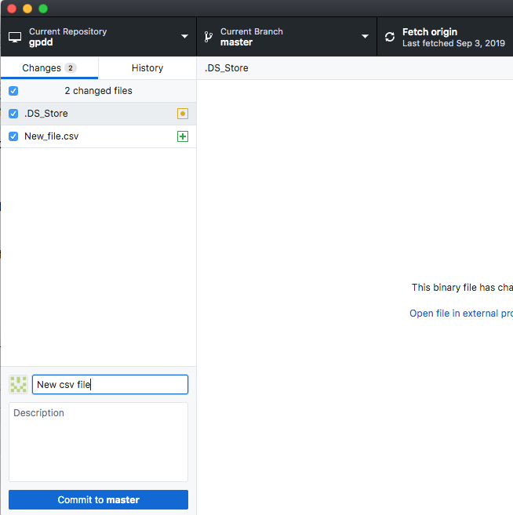

5) Next push your changes to the origin by clicking the blue “Push origin” button.

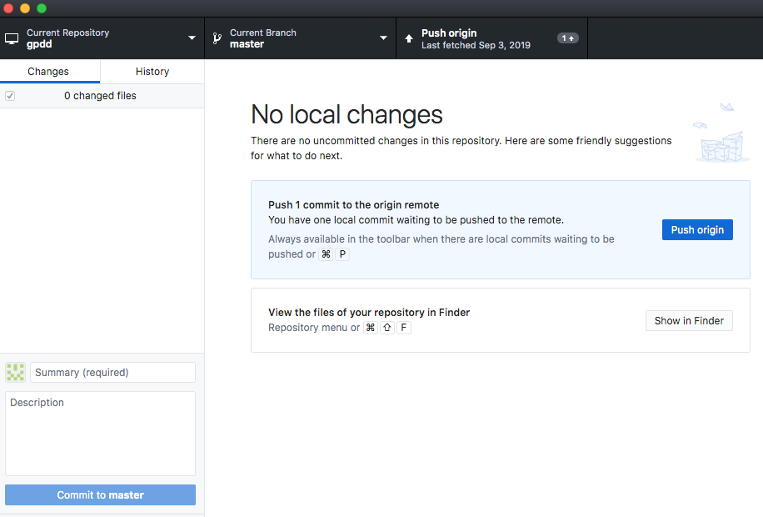

6) Next (I think) you will be asked to “Submit a pull request”, and then you wait for me to approve your file submissions.

7) If you get stuck, please come see me so I can figure out the problems.

**## 2) Create a file directly in the GitHub repository**

1) Open the Lab 2 directory of the class repository online.

2) Click on “Create new file” – you must be signed in to your Github account to do this.

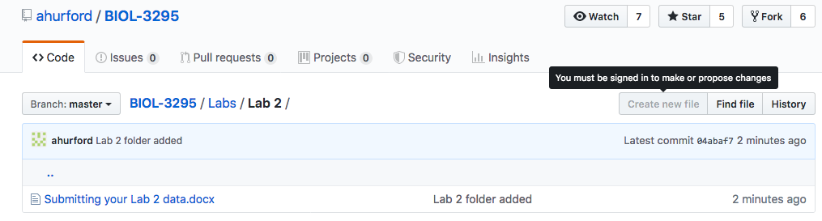

3) Enter your data similarly to “Example data entry.csv”:

* Each row must have exactly the same number of commas
* Place a comma where you would like to start a new column
* Do not add in any unnecessary spaces
* Words should be enclosed in “”.
* Name your file with the .csv extension and with a different name than any other files in the Lab 2 directory.

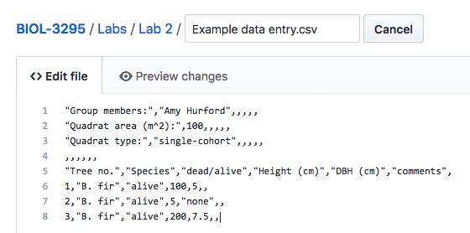

You may need to click the pen icon to be able to enter the data:

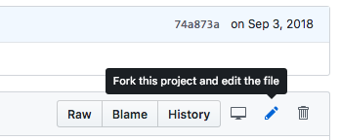

Note: A shortcut might be to enter your data into excel, save as a .csv file (see above for Instructions, if needed), then open the file in a text editor such as Microsoft Word or TextEdit, which should give a format similar to that shown above with commas and “”. Then copy and paste into the file you have created online on Github and add any missing features, i.e., for my test example this approach yielded all the commas that I needed, but didn’t produce the “” around the names. You could add this in after pasting onto the online file, or it should be fine to submit without these.

1. Once you have entered all your data into the file you’ve made online, please copy it and save a local version (as .csv or .txt) for your records, just in case there are problems, so you don’t have to re-enter the data again.
2. When you have finished then “Propose the file change” (or something similar, possibly “Commit changes” or “Submit a pull request”). Once the Pull request is submitted, I will be notified to review the changes and approve them for the repository. 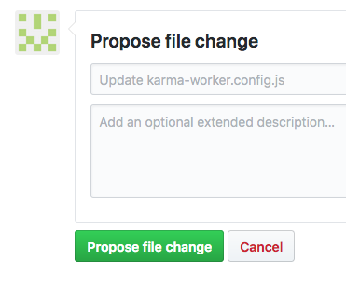
3. If you encounter problems, please come and see me so I can resolve them.